Berean Baptist Church
Founded 1874

Annual Meeting
January 28, 2024
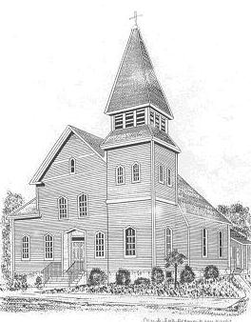
Reports and Business Summary
For the year 2023

Rev. Darin Collins, Pastor
Veronica Bessette, Moderator

We, the fellowship of Berean Baptist Church, worship one God who is revealed and accessible to each and every one of us regardless of race, ethnicity, gender, sexual orientation, gender identity and expression, age, social standing or all other abilities. All have been given the gift of accepting full participation in the Kingdom of God. God's grace, love, and mercy are given freely and unconditionally and extends to all people. Therefore, we accept, welcome and affirm all as brothers and sisters united in striving to live holy and acceptable lives in the service of God's Kingdom. May our hearts as well as our church doors remain forever open and welcoming to all of God's creation.

Table of Contents/Agenda

REPORTS OF THE PASTOR AND CHURCH OFFICERS Page(s)
Pastor’s Report 1-2
Clerk’s Report: Annual Meeting Minutes & Church Record 3-5
Treasurer’s Report:
Finance Reports (Operating & Program Budget and Investments 6-11
Assistant Treasurer’s Report: Contribution Entry

REPORTS OF THE DIACONATE COMMITTEES
Christian Education 12
Outreach 13-15 Stewardship (House & Finance) 16-17
Worship & Fellowship 18-19

REPORTS OF THE SUB-COMMITTEES
Pastoral Relations (Including Pastor’s Job Description) 20-21
CONGREGATIONAL DECISIONS
Old Business: ABCORI Report 22

New Business: Elect Delegates to ABCORI (Vote)
Discussion of Financial Budget
Adoption of Financial Budget (vote)
Discussion of the Preschool Lease
Preschool Lease (vote)
Discussion:
Joining Association of Welcoming and Affirming Baptists (AWAB)
Vote on joining AWAB
Re-election of the Pastor (vote)
Election of the Slate of Church Officers (vote)
Election of the Diaconate Committee Members (vote)
Presentation of "Second Mile Award."

CONCLUDING REMARKS (Moderator)

ADJOURNMENT

